UCS1601---Internet Programming

Assignment – 2

***Swetha Saseendran***

***CSE-C***

***185001183***

**Code:**

HTML File

<!DOCTYPE html>

<html>

<head>

    <meta charset="utf-8">

    <title>

        Grade Calculator

    </title>

    <!-- FONT AWESOME ICONS -->

    <script src="https://kit.fontawesome.com/08d11cd3e5.js" crossorigin="anonymous"></script>

    <!-- FONT LINKS -->

    <link rel="preconnect" href="https://fonts.gstatic.com">

    <link href="https://fonts.googleapis.com/css2?family=Bree+Serif&family=Pacifico&display=swap" rel="stylesheet">

    <!-- CSS FILE  -->

    <link href="Index.css" rel="stylesheet">

</head>

<body>

    <section id="getDetails">

        <div>

            <div id="signInDetails">

                <h1><strong> Grade Calculator </strong></h1>

                <form class="formStyling" id="form">

                    <div id=1 class="form-group rowStyling disappear">

                        <h2>

                            <label for="email"> Name</label>

                            <input type="text" name="name" class="form-control fieldStyling" id="name1">

                            <label for="marks"> Marks </label>

                            <input type="number" name="marks" class="form-control fieldStyling shrink" id="mark1">

                        </h2>

                    </div>

                    <div id=2 class="form-group rowStyling disappear">

                        <h2>

                            <label for="email"> Name</label>

                            <input type="text" name="name" class="form-control fieldStyling" id="name2">

                            <label for="marks"> Marks </label>

                            <input type="number" name="marks" class="form-control fieldStyling shrink" id="mark2">

                            <i id="b1" class="fas fa-trash icon" onclick="removeField(this);"></i>

                        </h2>

                    </div>

                    <div id=3 class="form-group rowStyling disappear">

                        <h2>

                            <label for="email"> Name</label>

                            <input type="text" name="name" class="form-control fieldStyling" id="name3">

                            <label for="marks"> Marks </label>

                            <input type="number" name="marks" class="form-control fieldStyling shrink" id="mark3">

                            <i id="b2" class="fas fa-trash icon" onclick="removeField(this);"></i>

                        </h2>

                    </div>

                    <div id=4 class="form-group rowStyling disappear">

                        <h2>

                            <label for="email"> Name</label>

                            <input type="text" name="name" class="form-control fieldStyling" id="name4">

                            <label for="marks"> Marks </label>

                            <input type="number" name="marks" class="form-control fieldStyling shrink" id="mark4">

                            <i id="b3" class="fas fa-trash icon" onclick="removeField(this);"></i>

                        </h2>

                    </div>

                    <div id=5 class="form-group rowStyling disappear">

                        <h2>

                            <label for="email"> Name</label>

                            <input type="text" name="name" class="form-control fieldStyling" id="name5">

                            <label for="marks"> Marks </label>

                            <input type="number" name="marks" class="form-control fieldStyling shrink" id="mark5">

                            <i id="b4" class="fas fa-trash icon" onclick="removeField(this);"></i>

                        </h2>

                    </div>

                    <br>

                    <button id="addStudent" name="addStudent" class="button" onclick="add()"> Add Student </button>

                    <button id="submit" name="submit" class="button" onclick="displayTable()"> Submit </button>

                </form>

            </div>

        </div>

        <div id="gradeTable" class="disappear">

            <table>

                <tr>

                    <th id="titleName"><strong> NAME </strong></th>

                    <td id="titleMark"><strong> GRADE </strong></td>

                </tr>

                <tr id="student1" class="disappear">

                    <th id="tableName1"></th>

                    <td id="grade1"></td>

                </tr>

                <tr id="student2" class="disappear">

                    <th id="tableName2"></th>

                    <td id="grade2"></td>

                </tr>

                <tr id="student3" class="disappear">

                    <th id="tableName3"></th>

                    <td id="grade3"></td>

                </tr>

                <tr id="student4" class="disappear">

                    <th id="tableName4"></th>

                    <td id="grade4"></td>

                </tr>

                <tr id="student5" class="disappear">

                    <th id="tableName5"></th>

                    <td id="grade5"></td>

                </tr>

            </table>

            <br>

            <button id="exitButton" class="button" onclick="exit()"> Exit </button>

        </div>

    </section>

    <script src="Index.js"></script>

</body>

</html>

CSS File

body {

  background-image: url("Welcome.jpg");

  background-size: cover;

  background-repeat: no-repeat;

  font-family: "Bree Serif", serif;

  text-align: center;

}

h1 {

  font-size: 3.5rem;

  font-family: "Pacifico", cursive;

  line-height: 2;

  margin-block-start: 0;

  margin-block-end: 25px;

}

table,

th,

td {

  border: 1px solid #071c24;

  margin-left: auto;

  margin-right: auto;

  text-align: left;

  padding: 10px 20px;

  font-weight: normal;

  font-size: 1.5rem;

  background-color: #aacfd0;

}

table {

  background-color: #071c24;

  border-width: thick;

  padding: unset;

}

td {

  text-align: center;

}

#titleName,

#titleMark {

  background-color: #79a8a9;

}

#getDetails {

  display: inline-block;

  position: fixed;

  top: 0;

  bottom: 0;

  left: 0;

  right: 0;

  margin: auto;

  background-color: #30475ed0;

  width: 80%;

  height: 300px;

  vertical-align: middle;

}

.icon {

  padding: 5px;

  position: absolute;

  left: 850px;

}

.icon:hover {

  color: #dc3545;

}

.rowStyling {

  margin: 10px;

  line-height: 1;

}

.fieldStyling {

  margin-left: 20px;

  margin-right: 20px;

  vertical-align: middle;

  padding: 2px, 10px, 2px, 5px;

  font-family: "Bree Serif", serif;

  font-size: 1.2rem;

}

.shrink {

  width: 70px;

}

.disappear {

  display: none;

}

.hide {

  visibility: hidden;

}

.button {

  padding: 7px;

  margin-left: 20px;

  margin-right: 20px;

  border-radius: 5px;

  border-width: 5px;

  border-style: unset;

  background-color: #3282b8;

  color: wheat;

  font-weight: 400px;

  font-family: "Bree Serif", serif;

  font-size: 1.2rem;

}

.button:hover {

  background-color: #0f4c75;

}

JS FILE

var studentCount = 0;

var rowcount =1;

var sectionheight = 300;

function add()

{

  var person = prompt("Add Student Name");

  var mark = prompt("Add Student Marks");

  studentCount++;

  sectionheight += 50;

  event.preventDefault();

  document.getElementById(studentCount).classList.remove("disappear");

  document.getElementById("name"+studentCount).value = person;

  document.getElementById("mark"+studentCount).value = mark;

  document

    .getElementById("student" + studentCount)

    .classList.remove("disappear");

  getDetails.style.height = sectionheight + "px";

  if (studentCount === 5)

  {

    document.getElementById("addStudent").classList.add("disappear");

  }

}

function removeField(element)

{

  var id = Number(element.id[1]) + 1;

  for (i = id; i < studentCount; i++)

  {

    document.getElementById("name" + i).value = document.getElementById(

      "name" + (i + 1)

    ).value;

    document.getElementById("mark" + i).value = document.getElementById(

      "mark" + (i + 1)

    ).value;

  }

  document.getElementById("name" + studentCount).value = "";

  document.getElementById("mark" + studentCount).value = "";

  document.getElementById(studentCount).classList.add("disappear");

  document.getElementById("student" + studentCount).classList.add("disappear");

  sectionheight -= 50;

  getDetails.style.height = sectionheight + "px";

  if (studentCount === 5)

  {

    document.getElementById("addStudent").classList.remove("disappear");

  }

  studentCount--;

}

function calculateGrade(mark)

{

  if (mark > 90)

  {

    return "A";

  }

  else if (mark > 80 && mark <= 90)

  {

    return "B";

  }

  else if (mark > 70 && mark <= 80)

  {

    return "C";

  }

  else if (mark > 60 && mark <= 70)

  {

    return "D";

  }

  else if (mark > 50 && mark <= 60)

  {

    return "E";

  }

  else

  {

    return "F";

  }

}

function displayTable()

{

  var alertcheck = 0;

  event.preventDefault();

  for (i = 1; i <= studentCount; i++)

  {

    var name = document.getElementById("name" + i).value;

    var mark = document.getElementById("mark" + i).value;

    if (name == "")

    {

      alertcheck = 1;

      alert("Please enter a name first!");

    }

    if (mark < 0 || mark > 100 || mark == "")

    {

      alertcheck = 1;

      alert("Marks should be between 0 and 100 .");

    }

    if (alertcheck == 1)

    {

      break;

    }

  }

  if (!alertcheck)

  {

    document.getElementById("form").classList.add("disappear");

    document.getElementById("gradeTable").classList.remove("disappear");

    getDetails.style.height = sectionheight + 70 + "px";

    for (i = 1; i <= studentCount; i++)

    {

      var name = document.getElementById("name" + i).value;

      var grade = calculateGrade(document.getElementById("mark" + i).value);

      document.getElementById("tableName" + i).innerHTML = name;

      document.getElementById("grade" + i).innerHTML = grade;

    }

  }

}

function exit()

{

  location.reload();

}

**Outputs:**

Home Page



Input Data through alert prompt

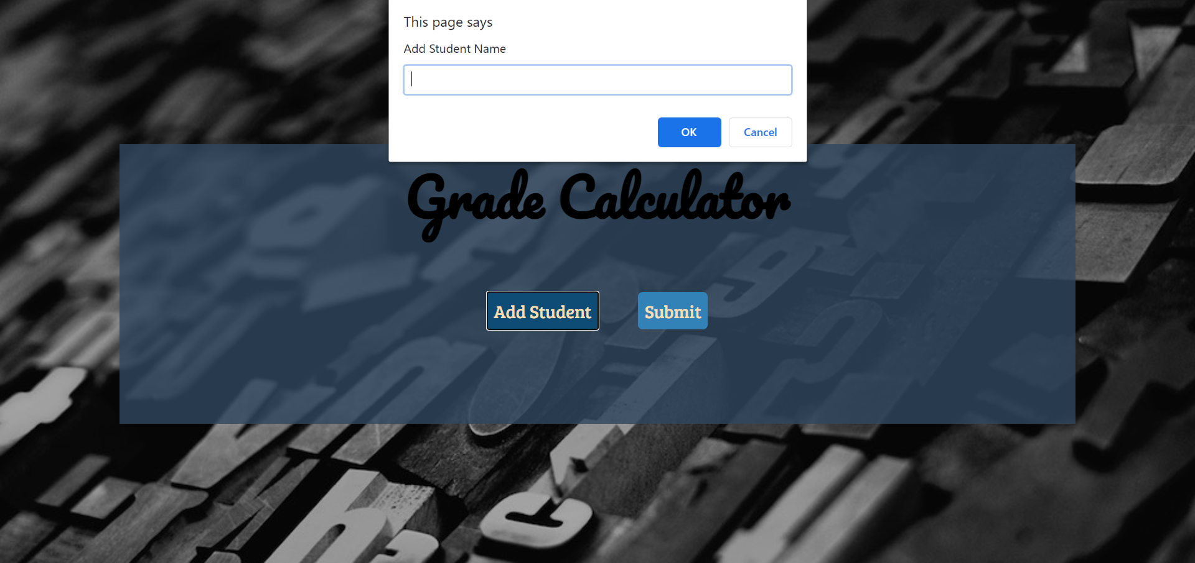



Add up-to 5 students (remove using the bin icon and edit in the textbox)

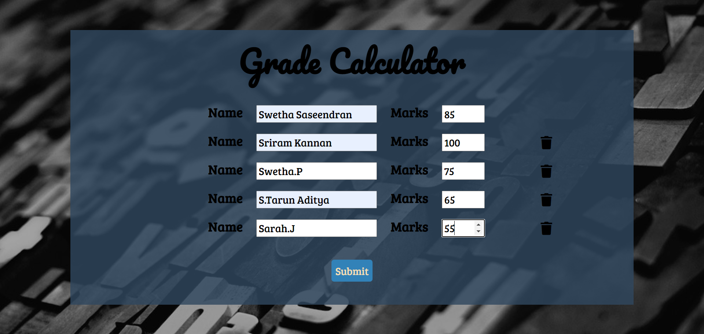

Table appears in clicking the submit button

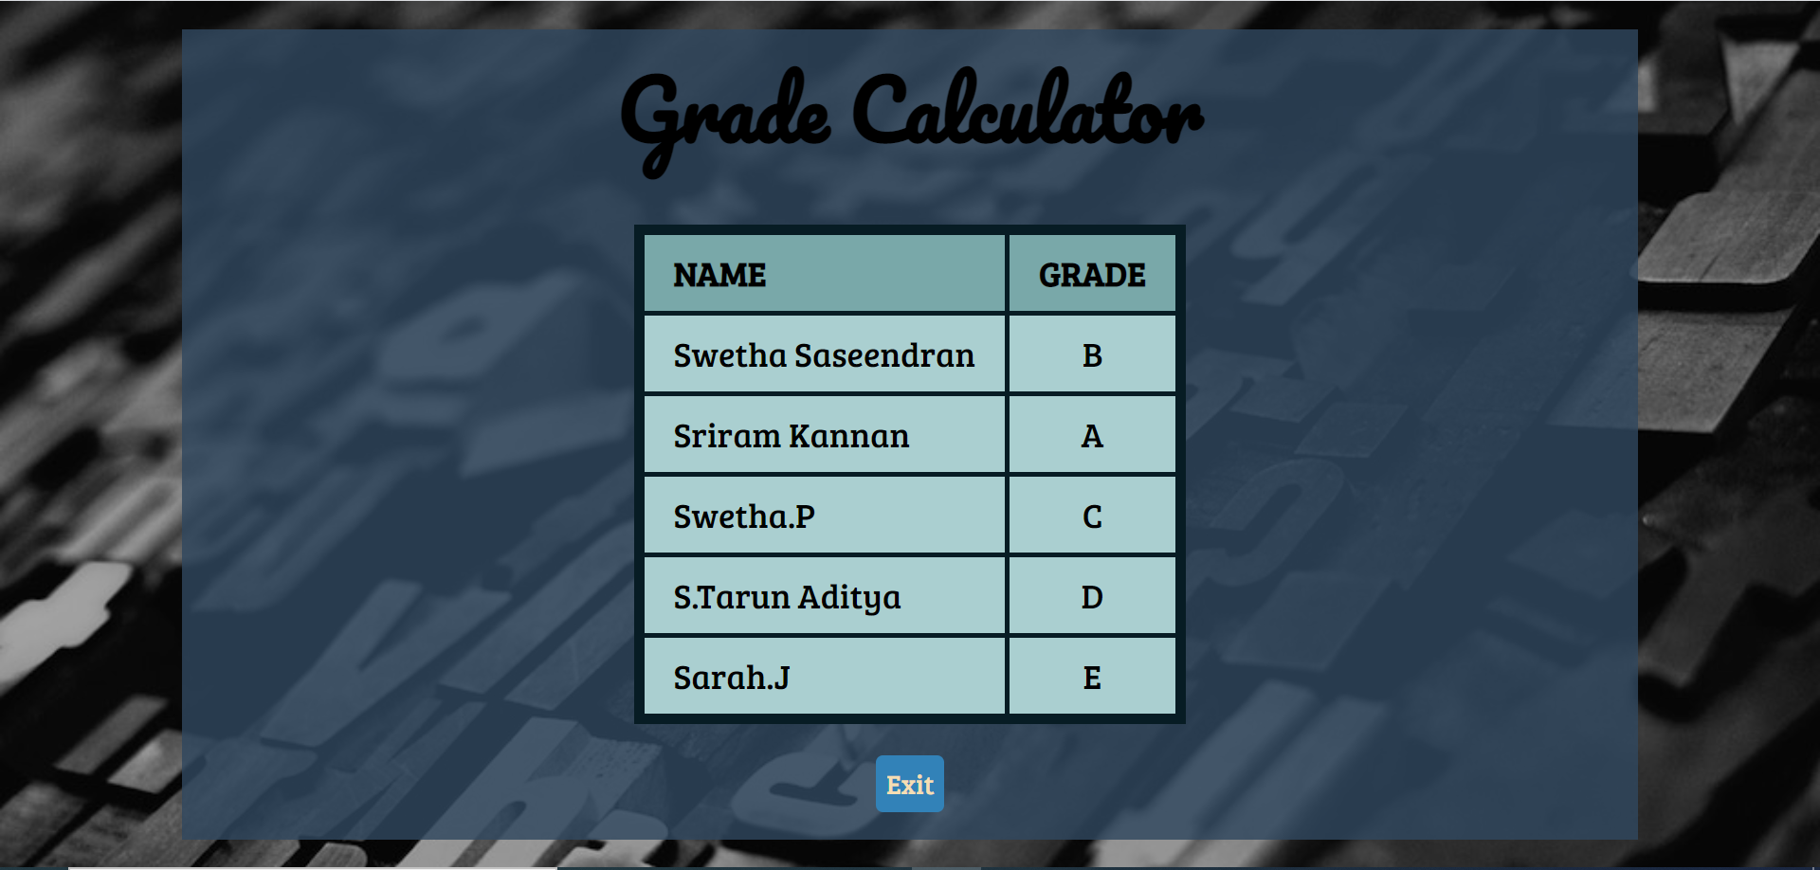

Alert if the name textbox is not filled.



Alert if the marks textbox is not filled or out of range.

